CS 340 README Project Two
Project Title: Grazioso Salvare Dashboard

About: This project is a Python-based application that integrates a CRUD (Create, Read, Update, Delete) module with a MongoDB database containing the Austin Animal Center (AAC) dataset. The CRUD module simplifies database interactions by allowing developers to retrieve and manipulate data without writing complex MongoDB queries.

Building on this functionality, an interactive dashboard was developed using the Dash framework to provide a user-friendly frontend interface. The dashboard allows users to filter dogs based on rescue categories, view geolocation data for selected animals, and visualize breed distribution through a dynamic chart. This combination of backend data processing and frontend visualization enables efficient exploration of the AAC dataset.

Motivation
The motivation for this project is to bridge the gap between a high-level Python application and a NoSQL database in a way that is both efficient and user-friendly. By encapsulating database logic within a Python class, the project promotes data integrity, improves code maintainability, and creates a reusable tool for future applications.

Additionally, the inclusion of an interactive dashboard transforms raw data into meaningful insights. This allows rescue teams, shelter staff, and other users to quickly access and interpret important information, such as available dogs and their suitability for different rescue roles. By combining a Python backend, a MongoDB database, and the Dash framework, this project delivers a practical and accessible solution for working with real-world data.

Steps Taken to Complete the Project
To get this program up and running, I used steps:
- Created MongoDB database and imported AAC dataset
- Developed CRUD Python module (Project One)
- Fixed constructor to use username/password authentication
- Built dashboard layout using Dash
- Implemented interactive filters using radio buttons
- Connected filters to MongoDB queries via CRUD module
- Created dynamic data table
- Added visualizations (chart + geolocation map)
- Tested all components using Jupyter Notebook
- Captured screenshots for documentation

Installation
You will need the following tools:
- Python 3.x: The primary programming language. This can be installed from the official Python website, pip is also installed when you download Python from the official website download. Chosen for its readability and extensive support for data science libraries. https://www.python.org/
- PyMongo: This was selected because it is the official MongoDB driver for Python. It provides a stable, high-level API that allows for seamless integration between Python dictionaries and BSON documents. Install it via terminal: pip install pymongo.
https://www.mongodb.com/
- Aac Database: A MongoDB database containing Austin Animal Center outcomes. You’ll need access to the database information or a local copy of the database information. https://pymongo.readthedocs.io/
- Dash (Plotly Framework): Dash is used to build the interactive web-based dashboard. It enables the creation of dynamic user interfaces using Python without requiring JavaScript. Install via terminal: pip install dash
https://dash.plotly.com/
- Pandas: A data analysis library used to structure and manipulate data retrieved from MongoDB. It is essential for converting query results into a format usable by the dashboard. Install via terminal: pip install pandas
- Plotly Express: A visualization library used to create interactive charts such as pie charts or histograms within the dashboard. Install via terminal: pip install plotly
https://plotly.com/python/
- Dash Leaflet: A mapping library used to create the geolocation chart for displaying animal locations on an interactive map. Install via terminal: pip install dash-leaflet
https://dash-leaflet.readthedocs.io/

Challenges and Solutions
During development, several technical challenges were encountered and resolved to ensure both backend stability and frontend functionality:
- Attribute Errors (Collection Referencing): An initial challenge involved correctly referencing the MongoDB collection. Early versions used self.database.animals, which caused inconsistencies and reduced flexibility. This was resolved by defining self.collection in the constructor, allowing all CRUD methods to reference the collection consistently and improving code modularity across environments.
- Variable Scoping in Exception Handling: A "local variable 'result' referenced before assignment" error occurred in the Delete method when an operation failed before the variable was assigned. This was resolved by restructuring the try/except block to ensure a valid return value is always provided, such as returning 0 when an exception occurs. This prevents runtime crashes and improves reliability.
- Dashboard Callback Data Alignment: A key challenge in Project 2 was ensuring that Dash callbacks returned data in the correct format for each component. Mismatches between the data table, chart, and map caused errors or prevented updates from displaying. This was resolved by carefully structuring callback outputs to match the expected formats (e.g., dictionaries for tables, DataFrames for charts) and ensuring consistency between components.
- Filter Logic and Query Design: Designing the filter options for rescue categories required careful mapping between user selections and MongoDB queries. Initially, overly strict queries resulted in limited or incorrect data being displayed. This was resolved by refining query logic and using techniques such as regular expressions to allow more flexible matching of breed names, ensuring accurate and meaningful results in the dashboard.
- Interactive Component Integration: Ensuring that all dashboard components (filters, table, chart, and map) updated dynamically was a challenge. Each component depends on shared data, and incorrect callback connections caused parts of the dashboard to fail. This was resolved by implementing Dash callbacks that link user input (radio buttons and table selection) to multiple outputs, enabling synchronized updates across all visual elements.

Usage
To initialize the project, the Austin Animal Center (AAC) Outcomes dataset was imported into a MongoDB instance using the mongoimport tool. Security was established by creating a user account (aacuser) with specific read/write permissions for the aac database.

The CRUD_Python_Module.py provides an object-oriented interface for database interaction. The AnimalShelter class handles authentication upon instantiation and includes the following methods:
- Create: Inserts a document into the collection. It returns True upon a successful insertion and False if the operation fails, utilizing exception handling to prevent crashes.
- Read: Queries the database using a dictionary-based filter. It processes a MongoDB cursor and returns the results as a Python list.
- Update: Queries for specific documents and applies changes using update_many. It returns the count of modified documents.
- Delete: Removes documents matching the provided criteria and returns the total count of removed records.
Testing was conducted via a Jupyter Notebook, which imports the module, instantiates the class with secure credentials, and executes each CRUD operation to verify data integrity and proper return values.

Code Example
Create:
def create(self, data):

# Inserts a document into the the specified MongoDB Collection
# Data = dictionary with Key/Value pairs
# Returns the data if true or else false

if data is not None:
# Tries to insert data first to see if it works
try:
self.collection.insert_one(data) # data should be dictionary
return True
# if insertion fails then it gets sent to here, displays message and returns false
except PyMongoError as e:
print(f"An error occurred during insertion process: {e}")
return False
# or else there was not data to be inserted
else:
raise Exception("Nothing to save, because data parameter is empty")
Expected Results:
- Returns: True when a document is successfully inserted
- Returns: False if an insertion error occurs
- Raises Exception if data is None
- A new document is added to the MongoDB collection
Read:
# Queries for the documents in the MongoDB collection
# Query = dictionary containing Key/Value pairs
# Returns a list of results if successful or else it returns an empty list

# Checks if query is None to prevent returning all documents accidentally
if query is not None:
# Tries to find a return cursor, then converts it to a list
try:
# Uses find()
cursor = self.collection.find(query)
return list(cursor)
# if there's an error it gets caught here with a display message and returns empty list
except PyMongoError as e:
print(f"An error occurred during query: {e}")
return []
else:
# Else the query is empty, create exception with display error method
raise Exception("Nothing to read, because query parameter is None")
Expected Results:
- Returns: A list of matching documents
- Returns: [] if no matching records are found
- Returns: [] if a query error occurs
- Raises Exception if query is None
- Output format: List of dictionaries representing MongoDB documents
Update:
def update(self, query, data):

# Function to update documents in the MongoDB collection
# Query = dictionary containing Key/Value pairs
# Data = dictionay with new set of values
# Returns number of documents updated

if query is not None:
# If there is a query, then try to update
try:
# Using update_many to handle one or multiple documents
# '$set' ensures we only change the specific fields provided
result = self.collection.update_many(query, {"$set": data})
return result.modified_count
# If there is an error, catch it here and display message with a return of 0
except PyMongoError as e:
print("An error occured during update: {e}")
return 0
else:
# Else the query is empty, create exception with display error method
raise Exception("Query is empty")
Expected Results:
  - Returns: Number of documents updated (e.g., 1)
  - Returns: 0 if no documents match the query
  - Returns: 0 if an update error occurs
  - Raises Exception if query is None
  - Updates only specified fields using $set
Delete:
def delete(self, query):

# Function that deletes a document from the MongoDB collection
# Query = dictionary containing Key/Value pairs
# Returns the number of documents removed

if query is not None:
# If there is a query, then try to delete
try:
# Uses the delete_many as that is the standard
result = self.collection.delete_many(query)
return result.deleted_count
except PyMongoError as e:
# If there is an error, catch it here and display message with a return of 0
print(f"An error occurred during deletion: {e}")
return 0
else:
# Else the query is empty, create exception with display error method
raise Exception("Query is empty")
Expected Results:
- Returns: Number of documents deleted (e.g., 1)
- Returns: 0 if no documents match the query
- Returns: 0 if a deletion error occurs
- Raises Exception if query is None
- Matching documents are permanently removed from the collection

Tests
from CRUD_Python_Module import AnimalShelter
# Create instance of AnimalShelter class
db = AnimalShelter("aacuser", "mongodb")
# ---------------------------
# TESTING CRUD OPERATIONS
# ---------------------------
print("**********************************************")
print(" TEST")
test_id = "123456"

# CLEANUP BEFORE TEST (prevents duplicates)
db.delete({"animal_id": test_id})

print("Before Insert:")
print(db.read({"animal_id": test_id}))

# CREATE
test_data = {
"animal_id": test_id,
"name": "Spudster",
"animal_type": "Dog",
"breed": "Golden Retriever",
"color": "Gold"
}

db.create(test_data)

print("After Insert:")
print(db.read({"animal_id": test_id}))

# UPDATE
db.update({"animal_id": test_id}, {"name": "Joe"})

print("After Update:")
print(db.read({"animal_id": test_id}))

# DELETE
db.delete({"animal_id": test_id})

print("After Delete:")
print(db.read({"animal_id": test_id}))
print("**********************************************")

Expected Results:
Create Operation:
- Returns: True
- Confirms the document was successfully inserted into the database
Read Operation:
- Returns: A list containing the inserted document
- Example: {'animal_id': 'TEST100', 'name': 'Spudster', 'animal_type': 'Dog', 'breed': 'Golden Retriever'}
Update Operation:
- Returns: 1
- Indicates that one document was successfully modified
Verify Update:
- Returns: Updated document with modified field
- Example: {'animal_id': 'TEST100', 'name': 'Spudster', 'animal_type': 'Dog', 'breed': 'Labrador Retriever'}
Delete Operation:
- Returns: 1
- Indicates that one document was successfully deleted
Verify Delete:
- Returns: An empty list []
- Confirms that the document no longer exists in the database

Result:
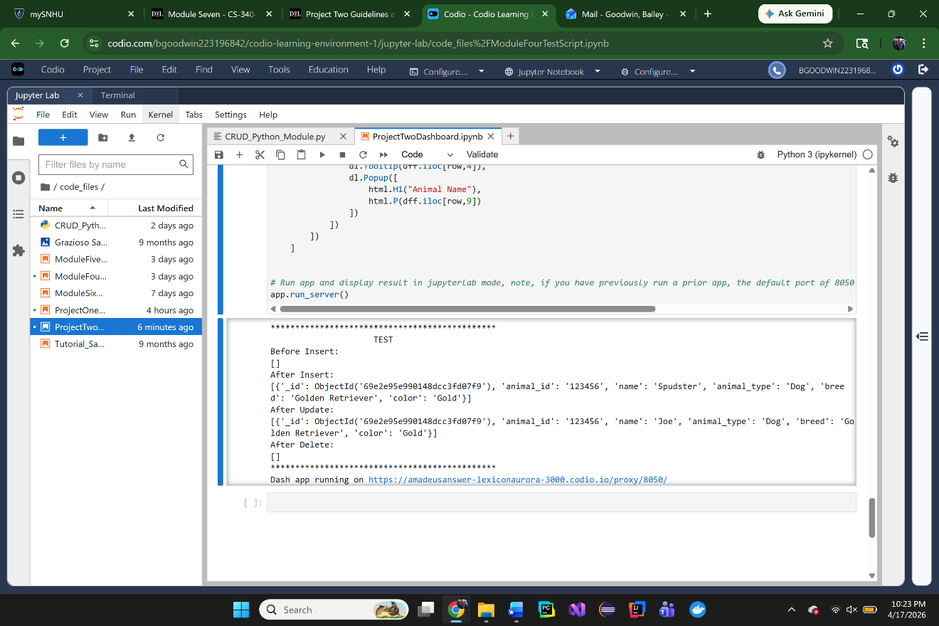

Dashboard Functionality
In addition to the backend CRUD functionality, an interactive dashboard was developed using the Dash framework to provide a visual and user-friendly interface for data exploration.
The dashboard includes the following features:
- Interactive Filtering Options: A radio button interface allows users to filter the dataset by rescue type, including Water Rescue, Mountain/Wilderness Rescue, Disaster/Tracking Rescue, and a Reset option to return all records. Each selection dynamically updates the displayed data using MongoDB queries executed through the CRUD module.
- Dynamic Data Table: A Dash DataTable displays the filtered AAC dataset. The table supports pagination, sorting, and row selection. It updates automatically based on the selected filter and provides a structured view of animal records.
- Geolocation Map: A Dash Leaflet map visualizes the location of selected animals based on latitude and longitude data. When a user selects a row in the data table, the map updates to display a marker for the chosen animal, including a tooltip and popup with breed and name information.
- Breed Distribution Chart: A Plotly Express chart (pie chart) dynamically displays the distribution of animal breeds based on the current filtered dataset. This provides a visual summary of breed frequency within each rescue category.
Testing of the dashboard was performed within a Jupyter Notebook environment using JupyterDash. Each filter option was verified to ensure correct database querying, and screenshots were captured to confirm proper functionality of the table, chart, and geolocation map under each rescue category and reset state.
Code Example
Data Filtering:
@app.callback(
[Output('datatable-id', 'data'),
Output('datatable-id', 'columns')],
[Input('filter-type', 'value')]
)
def update_dashboard(filter_type):
if filter_type == 'Water':
query = {
"animal_type": "Dog",
"breed": {"$in": ["Labrador Retriever Mix", "Chesapeake Bay Retriever", "Newfoundland"]},
"sex_upon_outcome": "Intact Female",
"age_upon_outcome_in_weeks": {"$gte": 26, "$lte": 156}
}
elif filter_type == 'Mountain':
query = {
"animal_type": "Dog",
"breed": {"$in": ["German Shepherd", "Alaskan Malamute", "Old English Sheepdog", "Siberian Husky", "Rottweiler"]},
"sex_upon_outcome": "Intact Male",
"age_upon_outcome_in_weeks": {"$gte": 26, "$lte": 156}
}
elif filter_type == 'Disaster':
query = {
"animal_type": "Dog",
"breed": {"$in": ["Doberman Pinscher", "German Shepherd", "Golden Retriever", "Bloodhound", "Rottweiler"]},
"sex_upon_outcome": "Intact Male",
"age_upon_outcome_in_weeks": {"$gte": 20, "$lte": 300}
}
else:
query = {}
results = db.read(query)
dff = pd.DataFrame(results)
if '_id' in dff.columns:
dff.drop(columns=['_id'], inplace=True)
columns = [{"name": i, "id": i} for i in dff.columns]
data = dff.to_dict('records')
return data, columns
Expected Results
- Updates the data table when a filter is selected
- Displays only records matching the selected rescue type
- Reset” returns all records
- Table updates dynamically without refreshing the page
Screenshots
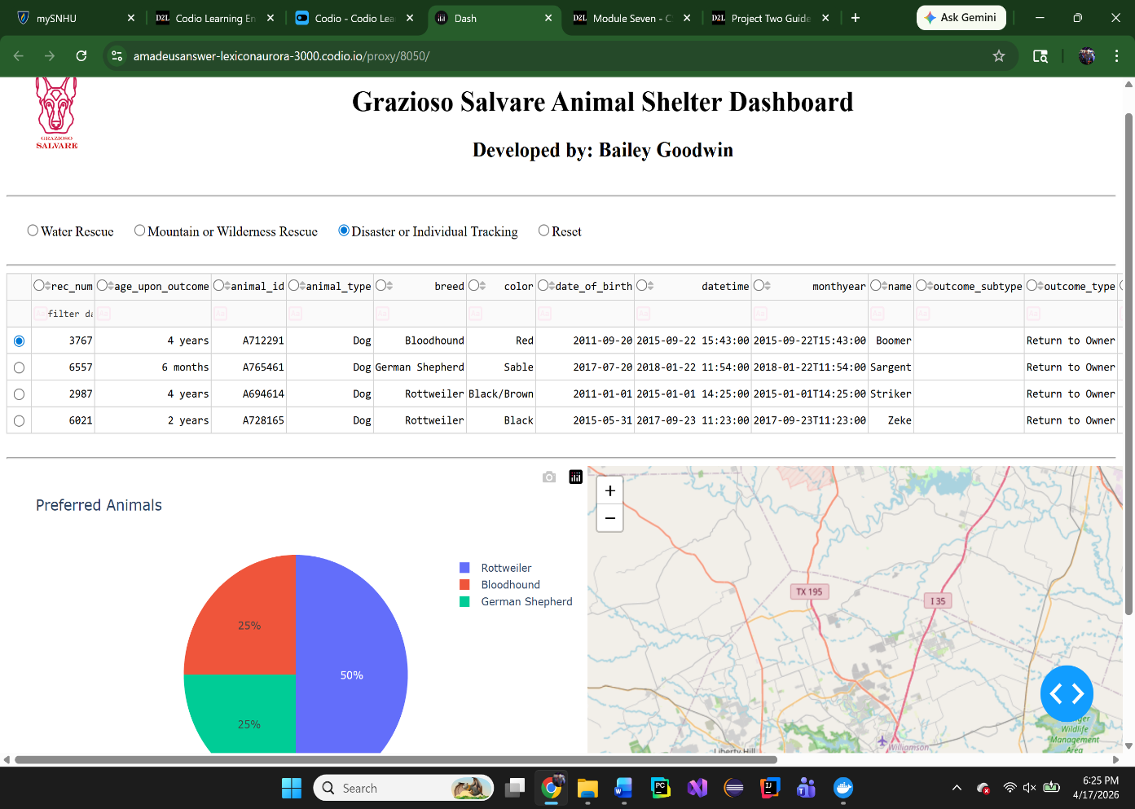

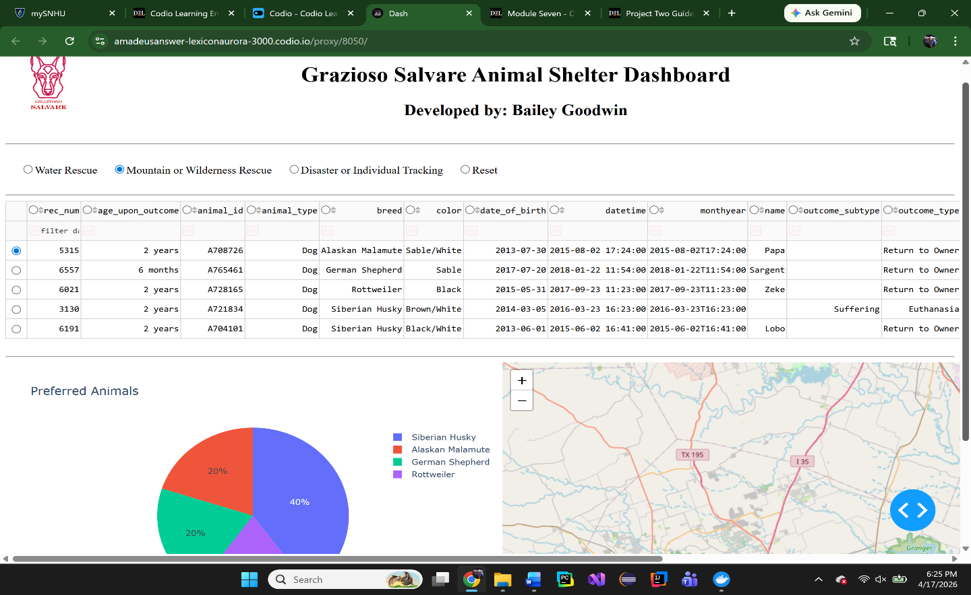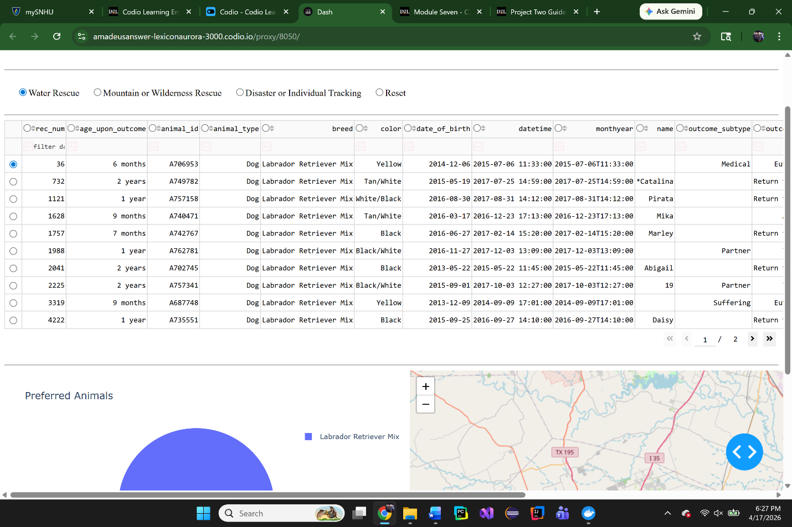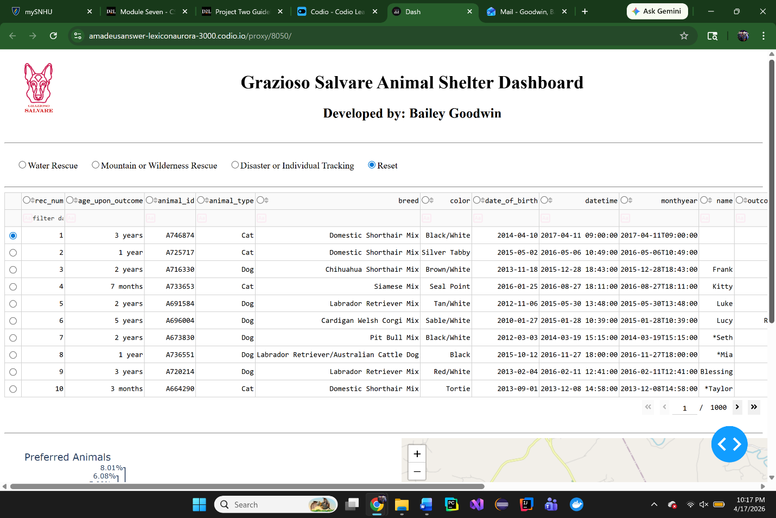

Table Highlighting:
@app.callback(
Output('datatable-id', 'style_data_conditional'),
[Input('datatable-id', 'selected_columns')]
)
def update_styles(selected_columns):
if not selected_columns:
return []
return [{
'if': {'column_id': i},
'background_color': '#D2F3FF'
} for i in selected_columns]
Expected Results
- Highlights selected columns in the table
- Improves readability and user interaction
- No errors occur if nothing is selected
Pie Chart Visualization:
@app.callback(
Output('graph-id', "children"),
[Input('datatable-id', "derived_virtual_data")]
)
def update_graphs(viewData):
if not viewData:
return []
dff = pd.DataFrame.from_dict(viewData)
return [
dcc.Graph(
figure=px.pie(dff, names='breed', title='Preferred Animals')
)]
Expected Results
- Displays a pie chart of animal breeds
- Updates automatically when the table data changes
- Reflects current filter selection
- Larger slices represent more common breeds
Geolocation Map:
@app.callback(
Output('map-id', "children"),
[Input('datatable-id', "derived_virtual_data"),
Input('datatable-id', "derived_virtual_selected_rows")]
)
def update_map(viewData, index):
if viewData is None or index is None:
return
dff = pd.DataFrame.from_dict(viewData)
row = index[0]
return [
dl.Map(center=[30.75, -97.48], zoom=10, children=[
dl.TileLayer(),
dl.Marker(
position=[dff.iloc[row, 13], dff.iloc[row, 14]],
children=[
dl.Tooltip(dff.iloc[row, 4]),
dl.Popup([
html.H1("Animal Name"),
html.P(dff.iloc[row, 9])
]) ] ) ]) ]
Expected Results
- Displays a map centered on Austin, TX
- Places a marker based on selected row data
- Tooltip shows breed information
- Popup displays the animal’s name
- Updates dynamically when a new row is selected
Screenshot
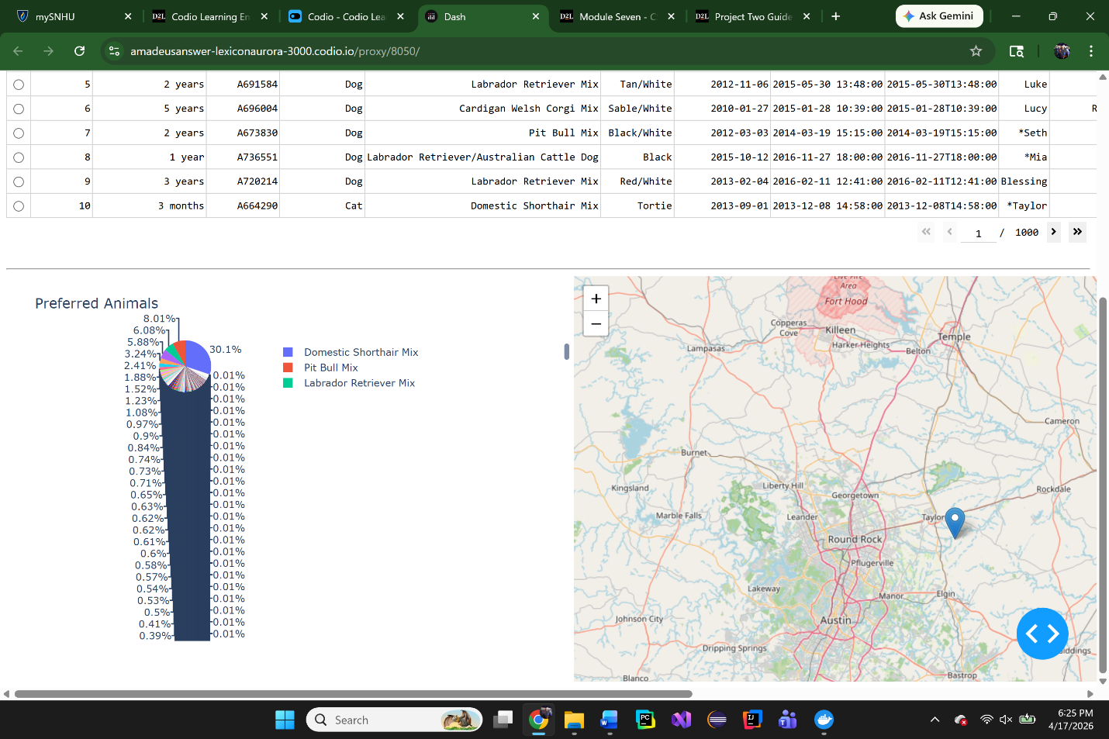

Contact
Bailey Goodwin

